Multiple-choice section

|  |  |  |  |  |  |  |
| --- | --- | --- | --- | --- | --- | --- |
| Question | 1 | 2 | 3 | 4 | 5 | 6 |
| Answer | C | A | C | C | C | C |

Question 1 [7.1]

C

Mark the letters O, A and H on the diagram.

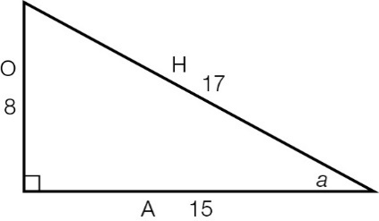



Question 2 [7.2]

A

Mark the letters O, A and H on the diagram.

|  |  |
| --- | --- |
|  | sin(θ) ==  =  *x* = × 35  *x* = 5 |

Question 3 [7.3]

C

Mark the letters O, A and H on the diagram.

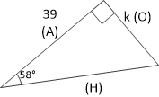

O and A can be used with the tan ratio: tan(58°) =

Question 4 [7.4]

C

Mark the letters O, A and H on the diagram.

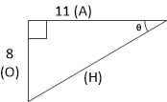

O and A can be used with the tan ratio: tan(θ) =

Question 5 [7.5]

C

|  |  |
| --- | --- |
| ACPM9_PR_7_05wssc | tan(43°) = , so *k* =  *k* = 11.5 m (1 d.p.) |

Question 6 [7.5]

C

329°T is between W (270°) and N (360°). It is 31°W of N (360° − 329° = 31°), so it’s written as N31°W.

Multiple-choice total marks: 6

Short answer section

Question 7 3 marks [7.5]

cos(θ) =

Length of adjacent side = 2.8 m

cos(θ) = 

Given cos(θ) = :



5*x* = 19.6

*x* = 3.92 m

Question 8 3 marks [7.5]

tan(θ) = 

tan(θ) = 



θ = 35°

The motorcyclist’s bearing from his starting point is 38°.

Question 9 3 marks [7.1]

**(a)** The hypotenuse is the longest side: 41 cm

**(b)**

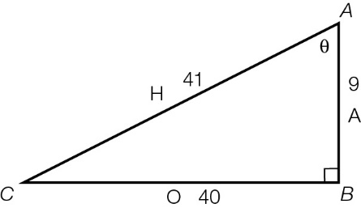

Question 10 4 marks [7.3]

|  |  |
| --- | --- |
| (a)  ACPM9_PR_7_10wssc_RR | sin(θ) =  sin(27°) =  *y* = 51.3 × sin(27°)  *y* = 23.3 m (1 d.p.) |
| **(b)** | tan(θ) =  tan(48°) =  *b* =  *b* = 21.5 m (1 d.p.) |

Question 11 4 marks [7.4]

|  |  |
| --- | --- |
| (a) sin(θ) =  θ =  θ = 33° | (b) tan(θ) =  θ =  θ = 52° |

Question 12 2 marks [7.3]

tan(48°) = 

*d* = 

*d* = 6.7 m (1 d.p.)

Question 13 3 marks [7.5]

|  |  |
| --- | --- |
| (a)  ACPM9_PR_7_12wssc | (b) tan(38°) =  *h* = 170 × tan(38°)  *h* = 132.8 m (1 d.p.) |

Short answer total marks: 22

Extended answer section

Question 14 6 marks [7.5]

(a) sin(θ) = 

sin(θ) = 

*h* = 9 × sin(56°)

*h* = 7.46 m

(b) cos(θ) = 

cos(56°) = 

*x* = 9 × cos(56°)

*x* = 5.03 m

(c) cos(θ) = 

cos(θ) = 



θ = 34°

The ladder is making an angle of 34° with the building.

Question 15 6 marks [7.5]

**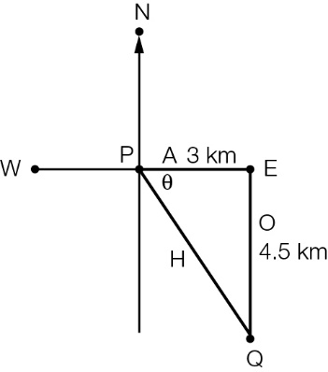**

**(a) (i)** tan(θ) = 

tan(θ) = 

θ = tan–1

θ = 58°

**(ii)** true bearing of *Q* from *P* = 90° + 58° = 148°T

**(b)** **(i)** Answer can be calculated using trigonometry or Pythagoras’ theorem.

Pythagoras’ theorem:

*c*2 = *a*2 + *b*2

*c*2 = 2.52 + 42

*c*2 = 22.25

*c* = 4.7 km (1 d.p.)

Trigonometry:

sin(58°) = 

H = 

H = 4.7 km (1 d.p.)

**(ii)** Total distance walked = 4.7 + 4 + 2.5 km

= 11.2 km

Extended answer total marks: 12

TOTAL test marks: 40